Mailroom Copier Code Setup for Windows 10

- Go to Printers and scanners

- Click on Mailroom Copier, then Manage
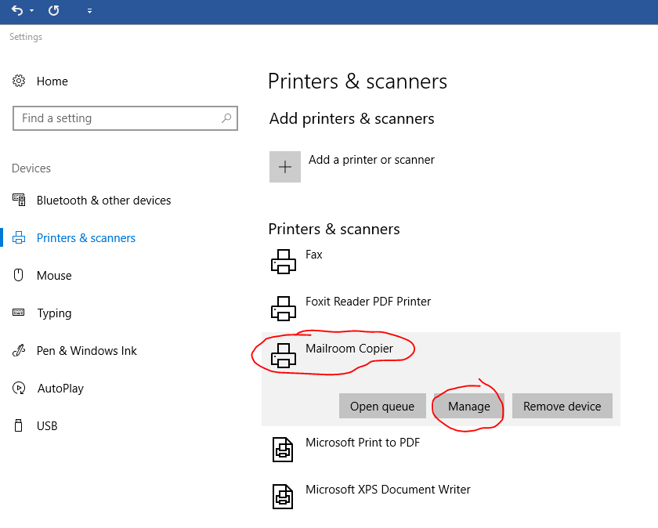

- Click on Printing Preferences, choose the Others Menu Tab, type in your Department copy code and click apply.
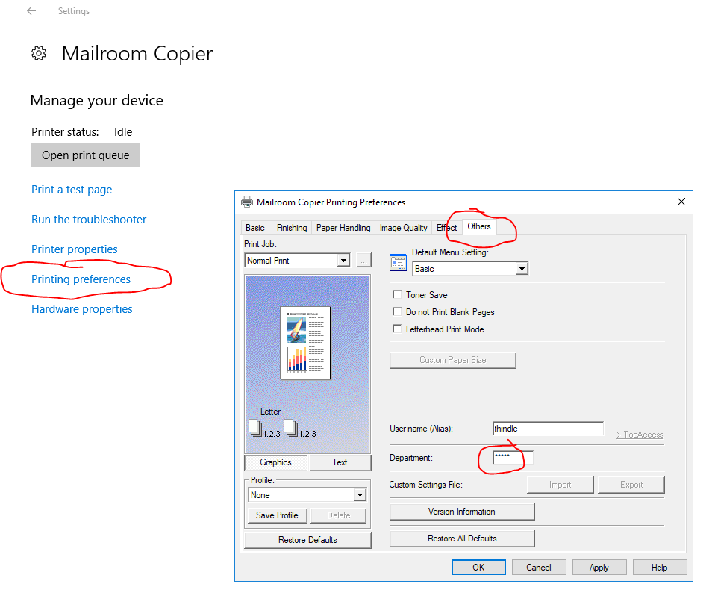

- For Graduate Students, you cannot print in Color so set your default under the Bascis Tab to Black and White.

