Program & abstracts
Florida Society of Geographers
51st anniversary Annual Meeting
1964 - 2015

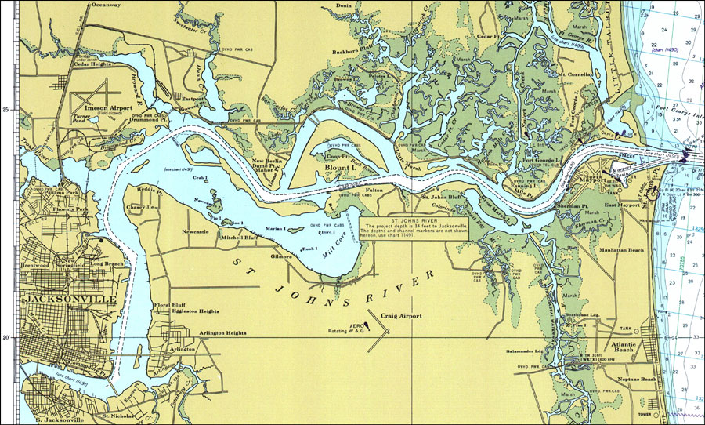
Jacksonville, Florida ~ 6-8 February, 2015
Crowne Plaza Jacksonville
Jacksonville, Florida

Hosted by
Jacksonville University, Jacksonville, Florida

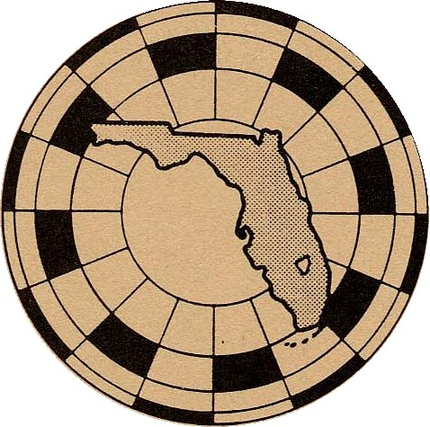
Florida Society of Geographers
(FSG)
1964-2015
2015 Board of Directors

President
Jeff Martin

Vice President
Christopher Whitaker

Secretary
R. Johns Krishnaswami

Treasurer
Mary Caravelis

Past President
Barnali Dixon

Student Representative
Kimberly Lyons

Executive Board Members
Ray Oldakowski
Mathew Cox
Ron Schultz
Laurie Molina

Editor, The Florida Geographer
Ray Oldakowski
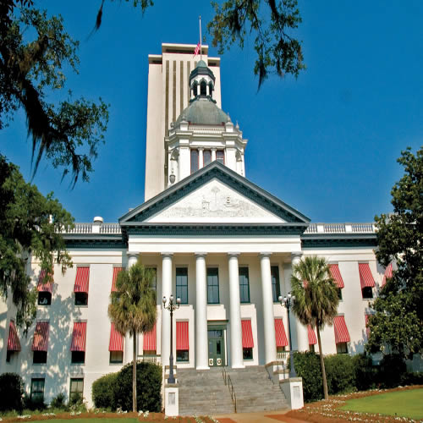

About our Organization
The Florida Society of Geographers was chartered in 1964 as a non-profit organization for the purpose of furthering professionalism in geography through application of geographic techniques in all areas of education, government, and business. The Society supports these objectives by promoting acquaintance and discussion among its members and with scholars and practitioners in related fields by stimulating research and field investigation, by encouraging publication of scholarly studies, and by performing services to aid the advancement of its members and the field of geography in Florida. The Florida Geographer is the official publication of the FSG and is available to the public on-line (http://journals.fcla.edu/flgeog).

FSG 2015 Conference Host
Crowne Plaza Hotel
1201 Riverplace Blvd
Jacksonville, Florida 32207
(904) 398-8800
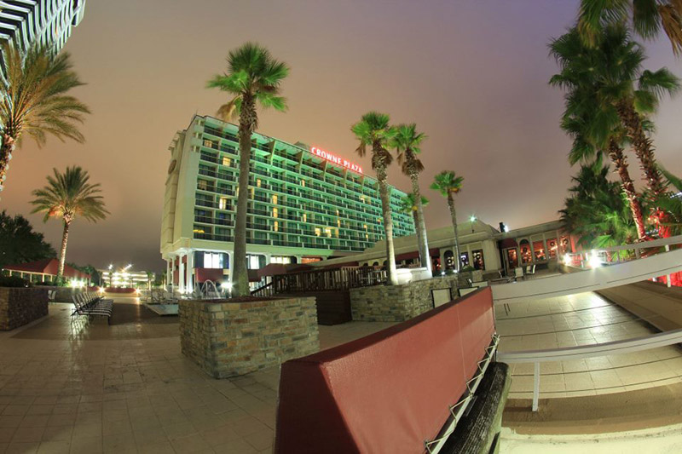

FSG Luncheon Banquet
University Club, Riverplace Building, Jacksonville, Florida
Adjacent and Next Door to the Crowne Plaza
The FSG Banquet will be held on The 27th Floor of the Riverplace Building on the South Bank of the St. Johns River in Downtown Jacksonville, Florida. Located at an s Curve in the River, this setting offers a unique view of the ST. johns to both the Northeast as it flows to the Atlantic Ocean and To the South as the water slowly arrives from its Watershed in Central Florida. This is an ideal venue for addressing the many challenges To this wonderful Waterway and one the Grandest physical features of Florida.

Keynote Speaker
Lisa Rinaman
The St. Johns River Keeper
‘Challenges for Florida and the St. Johns River in the 21st Century’

The St. Johns Riverkeeper is the chief advocate and public's voice for the St. Johns River. Responsibilities include: holding regulatory agencies and those polluting the river accountable; identifying and advocating for solutions that will protect and restore the river; working with government entities, businesses, community leaders and citizens to resolve problems that impact the river’s health; and communicating with the media and the public to educate and raise awareness about important river-related issues.
As a former senior staff member for Jacksonville Mayor John Peyton, Lisa Rinaman has extensive experience building consensus around issues and helped implement numerous environmental initiatives and policies. Lisa was instrumental in leading the effort to develop and implement irrigation, fertilizer and Florida Friendly landscaping ordinances to better protect the St. Johns and local waterways. She also played a key role in securing state funding for water quality improvements, organizing the city's successful Manatee Protection Plan, and pushing for programs necessary to fulfill the River Accord restoration plan for the Lower St. Johns River.
Before being named the St. Johns Riverkeeper, Lisa served as a valuable member of the St. Johns Riverkeeper Water Policy Group (WPG), a group that advocates for water conservation and reuse and policies that are more protective of our water resources.
Friday Social Gathering & Reception
Location: Amelia Room
Reception: 6:00 p.m. – 8:00 p.m.
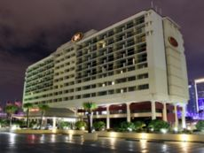
Crowne Plaza–Riverplace Jacksonville
Amelia Room

1201 Riverplace , Jacksonville, Florida, 32207,
Cash Bar and Light Snacks

Field Trip
“The St. Johns River: River of Lakes”
Saturday February 7th 2015 4:00 PM

The St. Johns River is the longest river and the largest watershed entirely in Florida. With 3.5 million people living within its drainage basin, it is facing numerous challenges in the 21st Century. Phosphate runoff, dredging, water extraction for human consumption, commercial use, and saltwater intrusion are all environmental concerns threatening the St. Johns River. Yet it remains a unique watershed and one of the most prominent geographic features in the state. The river flows 500 Kilometers from Indian River County to the Atlantic Ocean dropping less than 9 meters en route. With such a small vertical descent the river’s average current is only 0.13 ms⁻¹, and it is often stagnant. This creates large shallow lakes along the way, inducing the Native Timuquan of Florida to call it the River of Lakes. Here in Jacksonville the St. Johns is tidal, urban, and commercial, creating a unique set of issues to encounter where we must balance the economic needs of the community against the need to preserve the quality of this rich and important water source. Since the river is tidal in Jacksonville the St. Johns current flows south into low tides and north into high tides and the water is partially saline. On 7 February, the day of our field trip, high tide is at 12:00 Noon, and low tide is at 6:00 p.m. Hence, we will be touring the river approaching low tide and the current will be flowing north. Our tour of the St. Johns will be led by Dr. Quinton White, the Director of the Jacksonville University Marine Science Research Institute. Dr. White will discuss the unique character of the St. Johns River in Jacksonville, and he will address the issues it faces in the next decade and 21st Century.
*A comment on the direction of flow. Virtually everyone in Jacksonville believes that the Nile and the St. Johns are the only two rivers on earth that flow north. Some years ago I was asked to give a lecture on the St. Johns to the community at a local museum. When I informed the audience that this was not the case, they were outraged. “Certainly, the pull of gravity towards the bottom or the earth, the South Pole, far exceeds the pull of gravity to the center of the earth.” When I provided geographic proof by showing numerous maps of rivers across the globe flowing to the north, they were visibly hurt that this unique geographic fact was actually a myth. To ease their pain I showed that most of the rivers identified were in the former Soviet Union, hence communist rivers, which may not count. While happier with this thought they remained disheartened, and I was never asked to lecture again. If one must to print the truth or the myth, print the myth.
DR. Quinton White
Director: Jacksonville University Marine Science Research Institute
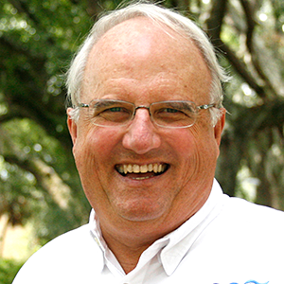
Field Trip Logistics

Please meet in the front lobby of the hotel at 3:45 PM. Das Boot will disembark from the Dock on the Southside of the St. Johns River adjacent to the Crowne Plaza.
We are using the St. Johns River Taxi. Unfortunately, The River Taxi does not have Debit or Credit Card imbursement capability so we will be required to pay cash. Please have exact change of $10, Available for the trip.

The Florida Society of Geographers (FSG) would like to express its deep gratitude to the Florida Geographic Alliance (FGA) for its financial support and sponsorship. The FGA has Promoted Geographic education at all levels in Florida and the success of the FSG’s annual meeting is largely because of the assistance provided by the FGA. Thank you!
Florida Geographic Alliance (FGA)

The Florida Geographic Alliance is a professional organization affiliated with the National Geographic Society of Washington D.C. and is housed at the Florida State University within the Institute of Science and Public Affairs. It is comprised of Primary, Secondary, Community College, and University Geography Educators, along with others interested in the enhancement of Geographic Education. Florida became a National Geographic Society Alliance State in 1988, and is governed by an Executive board selected by both the Alliance and State DOE Coordinators.

The Alliance also has an Advisory Board which serves as the main governing body of the Florida Geographic Alliance. This Advisory Board consists of the State Alliance Coordinator, the DOE Social Studies Program Specialist, 2 District Social Studies Supervisors, 2 University/College Geographers, 2 Elementary teachers, 2 Secondary teachers, 1 University Social Studies Educator, The President of the Florida Society of Geographers and 1 Community College Geography Educator. The Advisory Board meets at the Florida Council for the Social Studies Conference each October and at the Florida Society of Geographers annual meeting, which is usually held in February and the location rotates around the state. One third of the Board will be elected each year. The General Alliance population meeting takes place at the FCSS Annual Conference.

The Alliance plays a vital role in the development of the new Social Studies Curriculum as well as suggesting ways of implementing National Standards through the help of their understanding staff of Teacher Consultants and Geographic Educators. FGA’s main concern is the quality of geographic instruction in the state of Florida as well as the support of their teachers providing that instruction.

Visit the FGA website to learn more about this organization. http://fga.freac.fsu.edu

Dr. Edward A. Fernald, Co-Coordinator
E-mail: efernald@admin.fsu.edu

Dr. Laurie Molina, Co-Coordinator
E-mail: lmolina@admin.fsu.edu

Florida State University
Institute of Science and Public Affairs
C2200 University Center
Tallahassee, Florida 32306-2641
Voice: +1 850 644 2007
Fax: +1 850 644 7360

Crowne Plaza Meeting Room Floor Plan

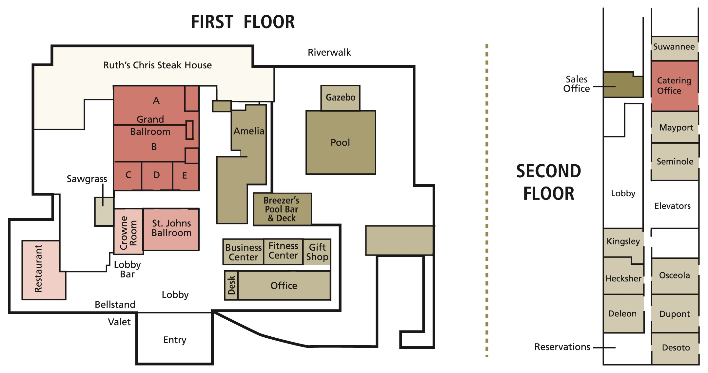Program at a Glance

Friday February 6, 2015

Registration, Amelia Room, Crowne Plaza 3:00 p.m. – 6:00 p.m.
Reception, Amelia Room, Crowne Plaza 6:00 p.m. -- 8:00 p.m.
Dinner – on your own

Saturday February 7, 2015

FSG Registration and Information
8:00 a.m. – 12:00 p.m. Registration..............………... Hallway in front of
Amelia Rm
Poster Session
8:00 a.m. – 8:00 p.m. Poster Display……………… Hallway in front of
Amelia Rm
9:55 a.m. –10:30 a.m. Poster Presenters Present
1:45 p.m. – 2:30 p.m. Poster Presenters Present
Paper Sessions
8:00 a.m. – 9:45 a.m. Sessions 1 & 2 Crowne & Amelia Rm
9:45 a.m. – 10:00 a.m. Break
10:00 a.m. – 11:15 Sessions 3 &4 Crowne & Amelia Rm

Luncheon Banquet and Keynote Address
University Club 11:30 a.m. – 1:45 p.m.
Riverplace Building: 27th Floor, Immediate east of the Crowne Plaza
Stairwell in the Lobby
Keynote Speaker: Lisa Rinaman, St. Johns Riverkeeper

1:30 p.m. – 3:30 p.m. Sessions 5 & 6 Crowne & Amelia Rms
3:30 p.m. Meet in lobby to carpool to the fieldtrip

FIELD TRIP 4:00 p.m. – 5:15 p.m.
St. Johns River

Sunday February 8, 2015
Business/Awards Meeting 9:00 a.m. – 11:00 am. Crowne Rm

Florida Society of Geographers
Best Graduate Presentation Award:
1st Place - $300
2nd Place - $150
Honorable Mention Presentation - $50

Florida Society of Geographers
Undergraduate Award:
The Harm J. deBlij Undergraduate Student Award - $200

Florida Society of Geographers
Best Poster - $100
Honorable Mention Poster - $50
The Undergraduate Award is made possible by a generous donation from the
H.J. deBlij Scholarship
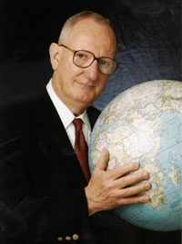
IN Memoriam to Harm J. de Blij 1935-2014
Paper and Poster Sessions
Great benefactor to the Florida Society of Geographers. His consistent participation and input at the FSG’s annual meeting was welcomed by all who shared time with Harm at these yearly gatherings. Harm’s congenial manner, dynamic personality, charisma, and true affection for geography in Florida will be missed by all. It was a great loss to our community and the FSG.
The Florida Society of Geographers wishes to recognize and remember the great contributions to geography in Florida by Harm de Blij. A true giant in our discipline, Harm was an enormous advocate and eloquent spokesman for geography across the nation, on television, in the classroom and in so many other forums. But as influential as Harm was at the national stage, he was also a stalwart supporter and great ogeography in Florida, and

Reminder to speakers:
If using a digital projector, please bring your file to the room at least ten minutes prior to the beginning of your session. Someone should be there to help you upload it onto the laptop. If not, proceed to upload your file so it will be ready to go at the allotted time. Each presenter will have 20 minutes for presentation with 10 minutes at the end for questions and answers for the group.
*Denotes graduate student presenter
**Denotes undergraduate student presenter

Saturday, February 7, 2015
Poster/Demo Session 8:00 a.m. - 6:00 p.m.
Room: Hallway in front of Amelia Room

Andreoli, Joseph A. University of Florida Graduate Student
Predicting the Geographic Ranges of Non-Native Cichlids in Florida with Climate Change
Armondo, Luzula and Derrick Scott Florida International University Undergraduate
Potential Causes of DUI Arrests in the Florida Keys
Buchanan, Jozzann, Florida International University Undergraduate
The Closing of Libraries is an Opportunity for Business
Espinal, Jeanne, Derrick Scott and Lourdes Ginart Florida International University Undergraduate
A Case Study of Equal Opportunity in the Miami School District; Rethinking Segregation and the Brown vs. Board of Education Ruling.
Ginart , Lourdes, Derrick Scott, Jeanne Espinal, Lourdes Ginart Florida International University Undergraduate
A Case Study of Equal Opportunity in the Miami School District; Rethinking Segregation and the Brown vs. Board of Education Ruling
Livingston, Karina Florida International University Graduate Student
The Capital of Latin America; Miami's Changing Demographics and Political Identity of the 21st Century
Neira, Cassandra and Kattiya Harris Florida International University Undergraduate
Florida Geographical Science Programs Database
Santander, Jimmy Florida International University Undergraduate
Early Frontier Acts Leading to Florida’s Population Boom
Terrano, Joseph University of South Florida Undergraduate
Determining Power Plant and Population Vulnerability to Storm Surges in Pinellas and Pasco County: A GIS Based Approach

Paper Session Number 1 8:00 a.m. – 9:45 a.m.
Climate Room: Crowne

Chair: Donna Stewart
Keellings, David: University of Florida Graduate
Investigating Teleconnection Drivers of Bivariate Heat Waves in Florida using Extreme Value Anlaysis
Zhou, Yao, Corene J. Matyas: University of Florida Graduate
Variations in tropical cyclone precipitation over Eastern United States (1951 to 2010)
Engstrom, Johanna, David Keellings, and Peter Waylen: University of Florida Graduate Student
The Sunshine State: Investigating External Drivers of Sky Conditions
Stewart, Donna, Barnali M. Dixon and Joseph Terrano: University of South Florida St. Petersburg
Florida’s Energy Infrastructure: Adaptation and Resilience in Response to Climate Change Vulnerability

Paper Session Number 2 8:00 a.m. – 9:45 a.m.
Human Geography Room: Amelia

Chair: Chuck Kovacik
Harris, Kittiya, Cassandra Neira: Florida International University Undergraduate
Florida Geographical Science Programs Database
Thornton, Benjamin: Florida State University Undergraduate
A Case Study of the Apalachicola Bay Oyster Industry
Kovacik, Chuck: University of South Carolina
Retirement Communities: Active Adults Only

Morning Break 9:45 a.m. – 10:00 a.m.

Paper Session Number 3: 10:00a.m. – 11:15 noon
Physical Geography: Water Room: Crowne

Chair: James Richardson
Merton, Elizabeth: University of South Florida St. Petersburg Graduate
Wetland delineation: a comparative study using multiple resolutions and algorithms
Douglas. Steven: University of South Florida St. Petersburg Graduate
Spatially Integrated Analysis of Surface and Groundwater Vulnerability to Nitrate Contamination
Richardson, James, Jessy Van Horn, Peter Waylen: University of Florida Faculty
Analysis of Changing Streamflow Characteristics of the Santa Fe River, Florida, 1932-

Paper Session Number 4: 10:0 a.m. – 11:15
Human Geography Room: Amelia

Chair: Tony Abbott
Strode, Georgianna: Florida State University Graduate Student
High-resolution population data: a data model using FDOR cadastral data and the US National Grid
Hall, Billy Florida: International University Graduate Student
Was it always a food desert?: Reconstructing the Colored Town food environment in Jim Crow Miami
Abbott, J. Anthony Stetson: University Faculty
William Bartram and Spatial Representation
Luncheon Banquet 11:30 a.m. – 1:30 p.m.
University Club: 27the Floor of the Riverplace Building
Keynote Speaker: Lisa Rinaman, St. Johns Rverkeeper

Paper Session Number 5: 1:30 pm. – 3:00 p.m.
Physical Geography Room: Crowne

Chair: Joann Mossa
Herrero, Hannah, Erin Bunting, Jane Southworth: University of Florida Graduate
USING RANDOM FOREST CLASSIFICATION TO IMPROVE SAVANNA LANDSCAPE ANALYSIS: A CASE STUDY OF CHOBE NATIONAL PARK, BOTSWANA FROM 1990 TO 2009
Lyons, Kimberly: University of South Florida: St. Petersburg Graduate
Sensitivity Analysis of SWAT to DEM Resolutions and Real versus Simulated Meteorological Data
Joann Mossa: University of Florida, and Sonila Papathimiu University of Tirana, Albania
Wetland and Land Use Changes near the Karavasta Lagoon, Albania: Concerns
and Prospects

Paper Session Number 6: 1:30 pm. – 3:00 p.m.
Geography Room: Amelia

Chair: Defne Sarlimaz
Hutton, Nicole S., Graham A. Tobin, Linda M. Whiteford: University of South Florida Graduate
Organizing Collective Action in the Non-Profit Sector Following the 2010 Earthquake in Christchurch, New Zealand

McKinney, Nathan: University of West Florida Graduate Student
Evaluating spatial compactness of Florida's "Fair District Amendment" legislative boundaries
Sarsilmaz, Defne; Florida International University, Graduate Student
Gendering Antakya: Re-configuring ethno-religious subjectivities among Arab-Alawite Women of Turkey

*Group will meet in the lobby at 3:45 p.m.*
Field Trip 4:00 pm -5:15 p.m. St. Johns River

Sunday, February 8, 2015

Business/Awards Meeting
Sunday 9:00 a.m. - 10:30 am.
Room: Cypress 2

Welcome
Approval of Minutes from Tallahassee meeting
Awards
Treasure’s Report
Report from Editor of The Florida Geographer
Elections
Old Business
New Business
Adjournment Have a safe trip back home…..
ABSTRACTS

Abstracts listed in alphabetical order of the lead author.

Paper Presentation Abstracts

Abbott, J. Anthony Stetson University Faculty
William Bartram and Spatial Representation

William Bartram published his seminal natural history in 1791, Travels through North & South Carolina, Georgia, East & West Florida, the Cherokee Country, the Extensive Territories of the Muscogulges, or Creek Confederacy, and the Country of the Chactaws. Though many maps of his journey have been produced in the last four decades, Bartram’s narrative is actually geographically enigmatic. The first popular map of his journeys appears in the Atlas of Early American History—archival evidence showing its production to be a costly and contentious affair—and this map has been reproduced several times by scholars and in popular texts. Three conditions of geographic knowledge matter for Bartram’s milieu, the information available to Bartram at his home in Philadelphia, the formal cartography and surveys in the regions he visited, and the informal knowledge held by his travel companions. Review of the of the information available in the Library Company of Philadelphia, the work of the Surveyor General for the Southern District, and consideration of the proprietary nature of location for traders illuminate the state of geographic knowledge for Bartram at the time he experienced his Travels. Ultimately it seems that despite his familiarity with formal cartography, Bartram chose to contextualize his travels in ways more in line with indigenous spatial representation.

Keywords Bartram, De Brahm, Maps, Indigenous

Douglas. Steven University of South Florida St. Petersburg Graduate
Spatially Integrated Analysis of Surface and Groundwater Vulnerability to Nitrate Contamination

Florida’s population has grown rapidly and that trend is expected to continue while contamination of limited freshwater resources continues. This situation has already created a long lasting crisis impacting the environment and human health, for example, from increased waste produced by on-site waste water systems. Nitrate is a contaminant of interest due to its carcinogenic properties, as well as association with several non-cancer health issues. To sustain water quantity needs in the future and protect human health, identifying vulnerable areas is critical. Utilizing a GIS to model nitrate sources, transport, and fate can be a cost effective tool to achieve this goal. However, separate models must be applied for the transport of nitrates to surface and groundwater. The objective of this project is to integrate two GIS models within watersheds in the SWFWMD to identify areas vulnerable to nitrate contamination. This project will use the specific vulnerability model, the Nitrate Vulnerability Index, for groundwater and the surface water loading model, ArcNLET. Water bodies and areas of vulnerable groundwater within a watershed will be ranked and an overall ranking of vulnerability for a watershed can be assigned. Overlaying the specific vulnerability maps for groundwater and loading model for surface water in a GIS allows us to focus water protection efforts, such as implementing best management practices, in areas of greater vulnerability.

Keywords Vulnerability, GIS, Groundwater, Surface Water, Nitrate, Human Health

Engstrom, Johanna, David Keellings, and Peter Waylen University of Florida Graduate Student
The Sunshine State: Investigating External Drivers of Sky Conditions

Referred to as the sunshine state, Florida is a popular tourist destination for sun lovers from all over the world. Not only do people come to visit, but there is also a net migration to Florida, and the state’s population reached a new maximum of 19.3 million in 2012 (U.S. Census Bureau, 2012). A growing population means a growing demand for electricity. In a time where the future of oil is uncertain and the impact of fossil fuel has proved to have a negative impact on the global climate, the opportunities for renewable energy sources should be thoroughly analyzed. In 2011 Florida ranked as the third largest net electricity producer from solar energy in United States, yet renewable energies (also including biomass, etc.) only contributed to 2.2% of the state’s total electricity production that year leaving over 250 trillion Btu of electricity to be imported from other states (U.S. EIA, 2011). One could therefore expect great potential and interest in further developing the solar industry which utilizes the most prominent of renewable energy sources in Florida. But how consistently sunny is Florida? This paper aims to explain variations in the number of clear sunny days in terms of the most dominant low frequency causes of climate variability in the Northern Hemisphere: El Niño Southern Oscillation (ENSO), North Atlantic Oscillation (NAO), Pacific-North American (PNA), and Atlantic Multi-decadal Oscillation (AMO). These and their associated patterns of teleconnections have all been presented as affecting the weather patterns of Florida in earlier peer-reviewed research.

Keywords Florida, solar energy, teleconnections, ENSO, AMO

Hall, Billy Florida International University Graduate Student
Was it always a food desert?: Reconstructing the Colored Town food environment in Jim Crow Miami

In the past decade, the “food desert” has become a powerful discursive metaphor, evoking a popular geographic imaginary of destitute food environments in poor communities – especially communities of color – and compelling public and private intervention to better supply these communities with healthy, affordable food. Recently, geographers have soundly critiqued the social construction of the food desert problem, questioning its methodological foundations, its tendency to victimize the poor, and its lack of recognition of histories of racial segregation and racist policy. This paper expands on these lines of critical engagement by interrogating and investigating the historical origins of one of Miami’s so-called “food deserts.” Drawing from methods in the spatial humanities, the paper presents an ethnohistorical account of a black community’s once viable food system before it was ultimately dismantled and reconfigured by urban renewal, slum clearance, and expressway construction. Combining spatial, archival, and textual data, this paper develops a spatial narrative of how a thriving multiracial and multicultural food business environment emerged in the context of Jim Crow segregation only to be undermined by liberal policies and programs of (re)development.

Keywords: food deserts, historical GIS, race, urban food systems, black businesses, geohumanities

Harris, Kittiya, Cassandra Neira, Florida International University Undergraduate
Florida Geographical Science Programs Database

Florida is a geographically diverse landscape that provides crucial material for research. From the issues of immigration, to the Gulf of Mexico, to the Everglades ecosystem, to hurricanes, to the Atlantic coastline, and more, Florida is a Mecca for scientific research. That our Florida Universities are leading the nation in Geographical Sciences is no coincidence. This research aims to create a useful database and strategic plan that Universities with Geographical Science departments can use to recruit future students. The database illustrated in this research will also inform students on the importance of Geographical Sciences and encourage their participation, which will in turn contribute to the advancement of this discipline. We have collected data from the course catalogs of every community college and high school within Florida to determine the schools that have adequate geography programs. For the community colleges, we documented the ones that have two or more geography or geographic information system courses. For the high schools, we documented the ones that have AP geography. This resource will become valuable to the six Florida Universities that offer undergraduate geography programs, and to the six Universities with a graduate program in the Geo-Sciences.

Keywords: Florida geographic education

Herrero, Hannah, Erin Bunting, Jane Southworth University of Florida Graduate
USING RANDOM FOREST CLASSIFICATION TO IMPROVE SAVANNA LANDSCAPE ANALYSIS: A CASE STUDY OF CHOBE NATIONAL PARK, BOTSWANA FROM 1990 TO 2009

The savanna systems of Southern Africa are an important dryland ecosystem because they cover up to 54% of this landscape and support a rich variety of biodiversity [1]. This paper evaluates the change in savanna vegetation along the Chobe Riverfront within Chobe National Park Botswana from 1990 to 2009 to determine if degradation is occurring and to what extent. Classifying land cover in savanna environments is challenging because the vegetation signatures are similar across distinct vegetation covers, e.g. shrub versus tree covers, due to the specific composition of savanna vegetation. Therefore, there are difficulties in making discrete clarifications in such landscapes. To address the issue of difficulty in classifying this landscape, the Random Forest Algorithm was applied to predict land-cover classes, and it was compared to a more traditional classification technique and vegetation indices methods and was found to be superior in terms of accuracy of results. This study indicates that there has been a transformation of vegetation in the Chobe Riverfront region, moving from grassland towards an increasing amount of bush/scrub vegetation. This could, in part, be due to an increasing number of elephants utilizing the Riverfront. The forested area at a further distance from the River has also had areas of loss of percent cover. This study provides land use planners and managers with a more reliable, efficient and relatively inexpensive tool for analyzing land-cover change across these highly sensitive regions, and highlights the usefulness of the Random Forest classification approach in savanna landscapes.

Keywords Savannas; degradation; land-cover change; remote sensing; Random Forest Classification

Hutton, Nicole S., Graham A. Tobin, Linda M. Whiteford, Florida State University Graduate
Organizing Collective Action in the Non-Profit Sector Following the 2010 Earthquake in Christchurch, New Zealand

Since the 2010 Darfield earthquake, Christchurch, New Zealand has experienced over 2,000 aftershocks, each of which has fostered a different emotional response amongst residents and consequently impacted their health and livelihood decisions. A study of 40 non-profits from 2013 to 2014 reveals that the connectivity of non-profits in Christchurch are vital to their ability to be effective for marginalized groups during recovery. Non-profit organizations continue to champion issues specific to marginalized groups throughout the recovery; however, both non-profit resources and the composition of marginalized groups they serve have changed due to structural damage and emotional strain. Many non-profits existing before the earthquakes benefitted from strong national directives and local collaboration that ensured continuation of services while adapting their local office operation strategies temporarily to address immediate earthquake related concerns. For many residents, though, especially those in the most affected geographic areas, maintenance of existing services was insufficient. Non-profit resident associations and city revitalization efforts emerged to organize volunteers and voice collective action priorities for the city’s future alongside government planning agencies. Four years after the first earthquake in Christchurch the recovery for the non-profit sector is marked by continued competition for funding, intentional awareness of staff stress, returning demand for service, increased outreach to migrant workers, and managed collaboration within the sector and with planning agencies. Change is still pending for some policy aspects that affect non-profits though: restrictions on place of operation will return in 2016 and advocacy energy to relocate various sectors within the future city has peaked.

Keellings, David University of Florida Graduate
Investigating Teleconnection Drivers of Bivariate Heat Waves in Florida using Extreme Value Anlaysis

Maximum and minimum daily temperatures from the second half of the 20th century are examined using a high resolution dataset of 833 grid cells across the state of Florida. A bivariate Extreme Value Analysis Point Process approach is used to model characteristics including the frequency, magnitude, duration, and timing of periods or heat waves during which both daily maximum and minimum temperatures exceed their respective 90th percentile thresholds. The temperature dataset is combined with indices of the El Niño-Southern Oscillation (ENSO), the Atlantic Multi-decadal Oscillation (AMO), and the North Atlantic Oscillation (NAO) to explore the influence of these oscillations on heat wave characteristics in Florida. In order to investigate the influence of a time varying signal (ENSO, AMO, NAO) on heat waves the signals are introduced into non-stationary models as covariates in the location and log-transformed scale parameters. The improvements to the model obtained by introducing covariates are examined using the deviance statistic whereby the difference in negative log-likelihood values between two models is tested for significance using a Chi-squared distribution. Results show improvement in the non-stationary models with the AMO and NAO covariates exhibiting spatially varying increases in the frequency, magnitude, and duration of heat waves. The AMO and NAO also appear to impact heat wave timing resulting in heat waves coming earlier in the summertime.

Keywords Climate, Teleconnections, Heat Waves, Extremes

Kovacik, Chuck
Retirement Communities: Active Adults Only
Active adult age restricted communities, also known as age-qualified communities, 55+ communities, or lifestyle communities are planned communities that offer homes and amenities that are attractive to older adults. These communities are organized to accommodate individuals who want to live in a community characterized by a relative age and income homogeneity rather than heterogeneity. They usually include a clubhouse or lifestyle center with a variety of activities including indoor and outdoor swimming pools, exercise facilities, craft rooms, Wall Street rooms, decks or patios for gathering, and golf. In most cases a younger spouse or significant other is permitted to live in the community as long as one member meets the minimum age requirement.
This paper provides a spatial and historical context concerning the location and layout of active adult age restricted communities. It examines how they evolved, factors that attract retirees to these communities, how they have influenced urban, social, and political landscapes. It also considers some basic information such as cost, amenities, and governance. Active adult age restricted retirement communities have been around since the 1950s, and despite estimates that they included over 12,000,000 residents in 2012, geographers have all but ignored this fast growing urban phenomenon.

Keywords: cultural geography, urban geography, immigration, demographic immigration, Miami, Latin America

Lyons, Kimberly University of South Florida St. Petersburg Graduate
Sensitivity Analysis of SWAT to DEM Resolutions and Real versus Simulated Meteorological Data

Managing and protecting Earth’s water resources is becoming increasingly important as the demand for clean water intensifies. Hydrologic models have been developed to assist planners and developers by projecting future changes in stream water quantity at the watershed scale. However, a model’s ability to accurately simulate watershed hydrologic response is highly dependent upon the quality of model inputs. Many of the world’s watersheds do not have access to high-resolution data such as Digital Elevation Models (DEM). The DEM is a key input for hydrologic models as it controls runoff potential as well as establishes watershed connectivity and hydrologic channels. Meteorological station data are also not available in many areas. For these areas, synthetic or simulated data can be generated. However, synthetic data may not simulate real meteorological data and subsequent hydrological responses. Therefore, understanding how different data inputs (real versus simulated and high versus low resolution) affect model results is imperative for model users. This research utilizes the hydrologic model SWAT (Soil and Water Assessment Tool) incorporated with ArcGIS to examine the sensitivity of SWAT model projected streamflow to changes in DEM resolution and meteorological source. The presented case study compares SWAT generated streamflow under four scenarios (30m DEM resolution with real meteorological data; 30m DEM resolution with simulated meteorological data; 90m resolution with real meteorological data; and 90m resolution with simulated meteorological data) to historical streamflow in order to evaluate the sensitivity to each data parameter and the combined effect of low DEM resolution and simulated meteorological data.

Keywords Environmental modeling, hydrology, water resources, GIS

McKinney, Nathan University of West Florida Graduate Student
Evaluating spatial compactness of Florida's "Fair District Amendment" legislative boundaries

In 2010 Florida voters overwhelmingly passed two constitutional amendments setting certain standards for committees to follow when drawing boundaries for congressional and legislative districts. In addition to banning plans favoring incumbents or parties, the amendments required that the shape of districts be contiguous and compact. These requirements have been the subject of extensive legal disputes partially due to subjective and poorly defined standards of “compactness.” This study attempts to measure district geographic compactness using a geospatial methodology that accounts for hard constraints such as water and state boundaries. Results of compactness measurement compared to previous boundaries, districts in other states, and various shapes could provide a valuable tool in evaluating current district compliance and overall effectiveness of the amendments.

Keywords, GIS, Florida, politics, redistricting

Merton, Elizabeth University of South Florida St. Petersburg Graduate
Wetland delineation: a comparative study using multiple resolutions and algorithms

Accurate and cost-effective wetland delineation is vital for wetland inventory and monitoring. Historically, digitization of aerial imagery has been used to delineate wetlands. Unfortunately, it is subjective, expensive and time consuming. However, traditionally poor resolution of satellite data made aerial imagery a viable alternative. With the advent of the new WorldView-2 satellites, the limitations of resolution associated with traditional satellite imagery no longer holds true. Therefore, there is a need to determine whether WorldView-2 imagery offers an alternative to classify images for wetland mapping. Furthermore, hand digitization is time consuming. Thus, automated classification with high-resolution satellite data could perhaps reduce cost. The results of this research will provide insight into the viability of WorldView-2 classified imagery and aid in decision making for agencies to use optimum methods of wetland mapping. Therefore, the goal of this study was to identify the most appropriate dataset and method for accurately identifying and mapping wetlands. This was achieved by comparing supervised and unsupervised classification algorithms (commonly used, readily available algorithms for ease of adaptation) using WorldView-2 satellite imagery to determine which executed the best results. These results were then compared to manually delineated wetlands using aerial imagery and existing wetland datasets to identify which dataset and which algorithm gave the best proximity of previously delineated wetlands. Additionally, the detailed cost and time invested was recorded for each method to determine the cost-effectiveness of each mapping approach. Future research will utilize these results to differentiate between natural wetlands and mitigated wetlands using fractal dimension analysis.

Keywords Wetlands, remote sensing, delineation

Mossa, Joann, *Sanila Papathimiu University of Florida Faculty *University of Tirana, Tirana, Albania
Wetland and Land Use Changes near the Karavasta Lagoon, Albania: Concerns and Prospects

Wetlands have been transformed worldwide through drainage to allow for growing crops, development and other reasons. This study investigates the timing and extent of land use change near the Karavasta Lagoon in Albania, a Ramsar site and an area of limited prior work using historical and more recent maps in a GIS. Following World War II, the communist government began the quest to drain wetlands to eradicate malaria and convert these landscapes to agricultural land. Despite some works that suggest there was some wetland drainage before World War II, the 1943 maps show no drainage canals; these increased from 330 km by 1967 and 671 km in a 540 km2 area by 1988. Another major loss was that of freshwater lakes, a favored habitat of the Dalmatian pelican. Between 1943 and 1967, Lake Teribufi (1641 ha) disappeared, followed by the loss of Lake Karavasta (478 ha) between 1967 and 1988. Between 1967 and 1988, 97 ha of reservoirs or artificial lakes were added. Outside of wetlands and lakes, this area was largely forested and had minimal agriculture in 1943; by 1988, about 88% of the forests and 80% of the wetlands were transformed to crops, grazing and orchards. This study gives insights to the timing and extent of changes surrounding an important wetland, likely undergoing profound losses in biodiversity and currently experiencing increased pressures associated with tourism and development.

Keywords, Wetlands, human impact, environmental change

Richardson, James, Jessy Van Horn, Peter Waylen University of Florida Faculty
Analysis of Changing Streamflow Characteristics of the Santa Fe River, Florida, 1932-2012

Annual mean, maxima, minima and flow duration curves are examined on the unregulated, rural Santa Fe drainage basin in north Florida, 1932-2012. Irrigation within the study area has more than doubled since the 1970s, increasing from about 3,400 hectares to about 7,300 hectares of irrigated land. This influenced a 22% decrease in minima and mean flows within the basin. Estimates of annual basin precipitation are made to determine whether the changes are driven by shifts in climate or regional sources of interannual variability. Various statistical tests objectively detect trends, breaks in the time series and significant changes in hydroclimatic characteristics. Low and intermediate flows exhibit marked declines after the break, and are reflected in the annual double mass and flow duration curves, yet changes are almost undetectable in precipitation. The absence of upstream flow regulation and major urban development, and strength of the signals at intermediate and low flows, suggest that the observed flow reductions result from the increased pumping of groundwater for irrigation in the mid-1970s.

Keywords Irrigation, stream flow, precipitation, Santa Fe River

Sarsilmaz, Defne; Florida International University, Graduate Student
Gendering Antakya: Re-configuring ethno-religious subjectivities among Arab-Alawite Women of Turkey

This paper traces the gendered discourse in Antakya and the ways in which it has been manifested in the everyday lives of Arab Alawite women. Antakya is a province on the Turkish-Syrian border, and was annexed from Syria under the French Mandate by the Republic of Turkey in 1939. Antakya contains the largest proportion of Arab citizens of Turkey, one-third of who are descendants of the Arab Alawites in Syria. Arab-Alawites have been marginalized throughout the Ottoman era and modern day Turkey through cultural, political and spatial discrimination. This paper traces the gendered discourse in Antakya and the ways in which it has been manifested in the everyday lives of Arab Alawite women. Antakya is a province on the Turkish-Syrian border, and was annexed from Syria under the French Mandate by the Republic of Turkey in 1939. Antakya contains the largest proportion of Arab citizens of Turkey, one-third of who are descendants of the Arab Alawites in Syria. Arab-Alawites have been marginalized throughout the Ottoman era and modern day Turkey through cultural, political and spatial discrimination. Through a feminist geopolitical lens, I explore the construction of ethnic, religious, and political subjectivities among Arab Alawite women in Antakya. I pay attention to their visibility in the public/private sphere and their mobility in everyday life particularly after the outbreak of the Syrian Civil War. I show how Arab-Alawite women empower themselves through actions such as sending their daughters to universities, establishing local businesses in historically masculinized sectors, and walking on the streets without being accompanied by men during hours seen as “inappropriate” for women. Through such actions, Alawite women are not only resisting a multiplicity of structures (the Turkish state, the patriarchal local society and masculinized spaces), but are also reconfiguring and reinscribing what it means to be an Arab Alawite woman in the ethnicized space of Turkish state. This paper uses data from extensive field notes from participant observation, Alawite women focus groups, and in-depth interviews with Alawite women, all collected during the summer of 2014 in Antakya.

Keywords: Antakya, Turkey, Arab Alawites, women, gender, feminist geopolitics

Stewart, Donna, Barnali M. Dixon and Joseph Terrano University of South Florida St. Petersburg
Florida’s Energy Infrastructure: Adaptation and Resilience in Response to Climate Change Vulnerability

This study provides a preliminary assessment of the state’s energy infrastructure’s vulnerability to the long term effects of climate change and acute weather events. Electricity generation infrastructure, such as power plants, is often located in coastal or low-laying areas. Much of this infrastructure, a key link in the state and national energy supply chain, is decades old and engineered under different climate assumptions. This pilot study first utilizes GIS and remote sensing techniques to determine the potential vulnerability of three power plants in Pinellas and southern Polk counties (Bartow, Bayboro, Anclote) to sea-level rise and storm surge events. The facilities’ adaptive measures, such as hardening and resiliency measures will then be assessed. The results of this preliminary study will be used to refine the assessment methodology for a state-wide analysis and recommend potential adaptation and resilience policy options.

Keywords Climate change, vulnerability, resilience, energy infrastructure

Strode, Georgianna: Florida State University Graduate Student
High-resolution population data: a data model using FDOR cadastral data and the US National Grid

Accurate population estimation is important in many fields of study, including
emergency management, access to healthcare, crime hotspots, and environmental
monitoring. Dasymetric cadastral-based population estimation techniques show high accuracy and resolution, yet have not made the transition from theory to practical application. This presentation demonstrates a data model that combines census data, FDOR cadastral data, and the US National Grid into a ready-to-use WebGIS format.

Keywords: census, dasymetric, population mapping, WebGIS

Thornton, Benjamin Florida State University Undergraduate
A Case Study of the Apalachicola Bay Oyster Industry

An overview of the problems facing the Apalachicola Bay region and the oyster production there. The major factors include water management in the headwaters, fishing policies, government intervention, as well as cultural and economic pressures to the region. The geographic methods used to study the situation include topics such as Remote Sensing, GIS, and Environmental Science.

Keywords Apalachicola Bay, Oysters, Remote Sensing, Environmental Issues

Zhou, Yao, Corene J. Matyas University of Florida Graduate
Variations in tropical cyclone precipitation over Eastern United States (1951 to 2010)

In this study, spatial and temporal variations of landfalling tropical cyclones precipitation (TCP) are analyzed from 60-year observational rainfall data by using geographic information system (GIS). Two hundred and twenty-six TCs affecting the U.S. over the 1951-2010 periods are examined. The daily precipitation amounts on 0.25°× 0.25° latitude-longitude grids are from the National Centers for Environmental Prediction (NCEP)-Climate Prediction Center Unified Precipitation Dataset (UPD). An automated extraction method is used to identify tropical cyclone precipitation. Then daily and storm-total TCP metrics are calculated, including areal coverage, extent, and average amount of precipitation. Then all TCP polygons are overlaid on equal-area hexagons that cover the eastern half of the United States. The result includes a series of maps with frequency distributions and an estimation of return intervals for tropical cyclone precipitation.

Keywords tropical cyclones, rainfall, GIS, observational data, spatial pattern

Poster Abstracts

Andreoli, Joseph A. University of Florida Graduate Student
Predicting the Geographic Ranges of Non-Native Cichlids in Florida with Climate Change

Non-native species and climate change are two of the most pressing issues facing Florida today. The state is a hotspot for non-native fish introductions, one group of these fishes are the cichlids. Cichlids are a popular group of fish in aquaculture, and among aquarists and anglers, with many species having established populations in Florida; and environmental, social, and/or economic impacts on the state. This study correlates the georeferenced presence points of different cichlid species in Florida and the current bioclimatic (BIOCLIM) and hydrologic (HYDRO1K) variables at those sites using maximum entropy modeling (MAXENT), in a species distribution modeling (SDM) framework. These relationships are then extrapolated to four different representative concentration pathways (RCPs) for the year 2050. The resulting maps give us predictions to where in Florida suitable habitat for a given species exists; all at a resolution matching that of the environmental variables of the model: 1 km2. Preliminary results indicate that the geographic ranges of cichlids do change on a species-by-species basis: a general trend being expansion of geographic range throughout the state. Findings may aid managers in prioritizing effort and resources in controlling the more impactful of the species. As eradication is difficult once a species becomes established, these models also have use in informing risk assessments of sister taxa. There is also predictive power in uncovering what parameters drive non-native cichlid ranges in Florida. Finally, these findings can be generalized to what variables are important for aquatic non-native species to become established in their introduced ranges globally.

Keywords Invasion ecology, species distribution modeling, climate change

Armondo, Luzula and Derrick Scott Florida International University Undergraduate
Potential Causes of DUI Arrests in the Florida Keys

DUI affects individuals, our community, and society in many negative ways. As a tourist destination, Florida and the state’s residents live with many of the repercussions of drinking and driving. This research is focused on Monroe County, the Florida Keys. We have collected data on the nearly 750 DUI arrests in the 1 year period of June 2012 – June 2013. A GIS has been created to understand the patterns of drinking in Monroe County. The bulk of the arrests were made on 3 islands. We then gathered data on the locations that serve or sell alcohol to see if a pattern emerges and find if there are places with low arrests but high drinking numbers. Finally we have begun preliminary data collection on the patterns of residency to ultimately find out whether there is equal distribution of arrests or are certain groups targeted. ​

Keyword

Buchanan, Jozzann, Florida International University Undergraduate
The Closing of Libraries is an Opportunity for Business

Libraries play an essential part in the community. The movement to close the Miami-Dade libraries caused uproar and prompted Major Gimenez to adjust a new budget proposal. Instead of all 49 libraries being closed it would now be 22. The purpose of this research would be to find out why those 22 libraries were chosen. In order to that Census and ArcGis will be utilized to create maps showcasing the reasons. The data that will be compared are Poverty percentages of individuals, Poverty Percentages of families and the House Values of the zip codes where the libraries are located. The data would show the potential business opportunities Miami-Dade could gain from selling the property values in those areas.

Espinal, Jeanne, Derrick Scott and Lourdes Ginart Florida International University Undergraduate
A Case Study of Equal Opportunity in the Miami School District; Rethinking Segregation and the Brown vs. Board of Education Ruling.

Historically and presently, America has been an example for the world, leading the way in providing equal opportunity for progress. It has been 60 years since the US court system made a precedent that separate but equal will not produce equal results. Though we do not have an institutionalized system that systematically segregates people based on race, the phenomena still exists with school systems today being as segregated as they were in the years leading up to 1954. This is largely due to what is called self-segregation or more likely limited opportunities for those without money or a strong voice in their community. School boundaries do not follow zip codes or even city boundaries, they are drawn based on the number of students that a school can accommodate. Using a geographic information system (GIS), this research takes a new approach to the subject of segregated education looking not only at race but also house values, and income. If our goal is to create an educated next generation with higher specialized education and training, then we cannot have schools that are failing. Good quality education should not be based on one’s street address.

Keywords Modern segregation, Brown v Board of Education, inequality,

Ginart , Lourdes, Derrick Scott, Jeanne Espinal, Lourdes Ginart Florida International University Undergraduate
A Case Study of Equal Opportunity in the Miami School District; Rethinking Segregation and the Brown vs. Board of Education Ruling

Historically and presently, America has been an example for the world, leading the way in providing equal opportunity for progress. It has been 60 years since the US court system made a precedent that separate but equal will not produce equal results. Though we do not have an institutionalized system that systematically segregates people based on race, the phenomena still exists with school systems today being as segregated as they were in the years leading up to 1954. This is largely due to what is called self-segregation or more likely limited opportunities for those without money or a strong voice in their community. School boundaries do not follow zip codes or even city boundaries, they are drawn based on the number of students that a school can accommodate. Using a GIS, this research takes a new approach to the subject of segregated education looking not only at race but also house values, and income. If our goal is to create an educated next generation with higher specialized education and training, then we cannot have schools that are failing. Good quality education should not be based on one’s street address.

Keywords Education

Livingston, Karina Florida International University Graduate Student
The Capital of Latin America; Miami's Changing Demographics and Political Identity of the 21st Century

South Florida and in particular Miami-Dade county has become an immigration hub. Unlike other cities with large immigrant populations, the majority of Miami’s immigrants are from Latin America. The assumption has been that it is a majority Cuban population, but in recent years it has become a destination for the whole of the Latin America’s diaspora. This research aims to understand the changing mosaic of populations carving their own place in Miami.
We have taken a particular notice of Little Havana, the neighborhood that has for decades been the entrance point for Cuban immigrants. Today the demographics of Little Havana are changing and Cuban immigrants have expanded to new parts of the city.
By analyzing data from Homeland Security and Census over the last 15 years, we will be able to see the trend of new immigrants entering the county and where they are settling down. To what extend are other Latin American’s moving in to Little Havana? Where are Cuban immigrants moving? Do Cubans still hold a vast majority of immigrants in Miami? How do the population demographics affect the economic and political power structure in Miami?

Keywords: cultural geography, urban geography, immigration, demographic immigration, Miami, Latin America

Neira, Cassandra and Kattiya Harris Florida International University Undergraduate

Florida is a geographically diverse landscape that provides crucial material for research. From the issues of immigration, to the Gulf of Mexico, to the Everglades ecosystem, to hurricanes, to the Atlantic coastline, and more, Florida is a Mecca of scientific research. That our Florida Universities are leading the nation in Geographical Sciences (Geo-Sciences) is no coincidence. This research aims to create a useful database and strategic plan that Universities with Geo- Science departments can use to recruit future students. The database illustrated in this research will also inform students on the importance of Geographical Sciences and encourage their participation, which will in turn contribute to the advancement of this discipline. We have collected data from the course catalogs of every community college and high school within Florida to determine the schools that have adequate geography programs. For the community colleges, we documented the ones that have two or more geography or geographic information system courses. For the high schools, we documented the schools that offer AP geography. This resource will become valuable to the six Florida Universities that offer undergraduate geography programs, and to the six Universities with a graduate program in the Geo-Sciences

Santander, Jimmy Florida International University Undergraduate
Early Frontier Acts Leading to Florida’s Population Boom

With Florida’s population anticipated to surpass 30 million in 2040 and the current population just trailing behind New York’s 19.65 million with an approximation of around 19.55 million, one has to wonder how the state of Florida went from a population of roughly 60,000 when granted statehood in 1845, to a boom of 19.44 million in less than 170 years. What exactly lured thousands of settlers to claimed land in an almost uninhabitable and harsh environment? How did their actions pave the way for Florida’s prosperity? The United States government passed the Armed Occupation Act of 1843 and the Southern Homestead Act of 1866 to help settle the lands in which “Injun savages” still wandered. Both acts gave settlers incentives for meeting certain guidelines on their claimed lands. Additionally, the United States government would reward settlers with extra acres of land if they “controlled” the Native American population still prevalent in Florida at that time. Is there a correlation between Florida’s population boom and these two aggressive acts passed by congress to push for southern expansion and eradicate Florida’s very own indigenous community? This study focuses on historical census data to convey the early days of Florida’s formation and its turbulent history of settlers claiming Native American lands and how the United States government endorsed this.

Terrano, Joseph University of South Florida Undergraduate
Determining Power Plant and Population Vulnerability to Storm Surges in Pinellas and Pasco County: A GIS Based Approach

This pilot project seeks to determine the vulnerability of power plants to storm surges and potential impacts of an adverse event on nearby populations and the natural environment. The pilot study area includes the Bartow and Bayboro Power Plants in Pinellas County, the Anclote Power Plant in Southern Pasco County, and their service areas. GIS and remote sensing techniques will be utilized to develop a method for analyzing and assessing the environmental vulnerability of the power plants and the subsequent social and environmental vulnerability of the areas these power plants service. Determining environmental vulnerability requires data on flood risk analysis, storm surge potential, land elevation, and both the power plant and its service areas’ proximity to coastal waters. The storm surge data will be mapped according to hurricane category, and its corresponding storm surge heights, to determine areas impacted by each storm category. Social vulnerability will be assessed using the demographic characteristics of age, race, gender, education, and access to transportation. These data will be overlaid to identify vulnerable population to storm surges and the associated power loss. The final result will be GIS maps depicting the power plants’ environmental vulnerability, along with the corresponding service areas’ social and environmental vulnerability.

Keywords GIS, storm surge, vulnerability, Power plants

FSG HONOREES
The Florida Society of Geographers (FSG) was chartered in 1964 as a non-profit organization for the purpose of furthering professionalism in geography through application of geographic techniques in all areas of education, government, and business. Please join us in honoring a few of the FSG founders and long-time members, as we thank them for their years of service and dedication to this organization.

Dr. Ronald Schultz, Department of Geosciences, Florida Atlantic University
Dr. Klaus Meyer - Arendt, Department of Geography, West Florida University
Mr. Storm Richards,
Dr. Jeanne Richards

